DATA ANALYSIS OF LIVABLE CONDITIONS IN SELECTED CITIES IN INDIA BASED ON SUSTAINABLE DEVELOPMENT GOALS

A SOCIALLY RELEVANT MINI PROJECT REPORT

Submitted by
R. SANJNA SUKIRTI 211423104583

in partial fulfillment for the award of the degree of
BACHELOR OF ENGINEERING

in

COMPUTER SCIENCE AND ENGINEERING


PANIMALAR ENGINEERING COLLEGE
(An Autonomous Institution, Affiliated to Anna University, Chennai)

OCTOBER 2025

PANIMALAR ENGINEERING COLLEGE

(An Autonomous Institution, Affiliated to Anna University, Chennai)

BONAFIDE CERTIFICATE

Certified that this project report “DATA ANALYSIS OF LIVABLE CONDITIONS IN SELECTED CITIES IN INDIA BASED ON SUSTAINABLE DEVELOPMENT GOALS” is the bonafide work of R. SANJNA SUKIRTI [211423104583] who carried out the project work under my supervision.

Signature of the HOD with date | Signature of the Supervisor with date
DR L.JABASHEELA  M.E., Ph.D., | DR M. KRISHNAMOORTHY  M.E., M.B.A., Ph.D.,
PROFESSOR AND HEAD,  Department of Computer Science and Engineering,  Panimalar Engineering College,  Chennai – 123. | SUPERVISOR ASSOCIATE PROFESSOR  Department of Computer Science and Engineering,  Panimalar Engineering College,  Chennai – 123.

Certified that the above candidate was examined in the 23CS1512 - Socially Relevant Mini Project Viva-Voce Examination held on ..............................

INTERNAL EXAMINER EXTERNAL EXAMINER

DECLARATION BY THE STUDENT

I, Sanjna Sukirti. R., (211423104583) hereby declare that this project report titled “Data analysis of livable conditions in selected cities in India based on Sustainable Development Goals”, under the guidance of Dr. M. Krishnamoorthy is the original work done by me and I have not plagiarized or submitted to any other degree in any university.

Sanjna Sukirti. R.
(211423104583)

ACKNOWLEDGEMENT

Our profound gratitude is directed towards our esteemed Secretary and Correspondent, Dr. P. CHINNADURAI, M.A., Ph.D., for his fervent encouragement. His inspirational support proved instrumental in galvanizing our efforts, ultimately contributing significantly to the successful completion of this project

We want to express our deep gratitude to our Directors, Tmt. C. VIJAYARAJESWARI, Dr. C. SAKTHI KUMAR, M.E., Ph.D., and Dr. SARANYASREE SAKTHI KUMAR, B.E., M.B.A., Ph.D., for graciously affording us the essential resources and facilities for undertaking of this project.

Our gratitude is also extended to our Principal, Dr. K. MANI, M.E., Ph.D., whose facilitation proved pivotal in the successful completion of this project.

We express our heartfelt thanks to Dr. L. JABASHEELA, M.E., Ph.D., Head of the Department of Computer Science and Engineering, for granting the necessary facilities that contributed to the timely and successful completion of project.

We would like to express our sincere thanks to Project Coordinator and Project Guide Dr. M. KRISHNAMOORTHY M.E.,M.B.A.,Ph.D., and all the faculty members of the Department of CSE for their unwavering support for the successful completion of the project.

SANJNA SUKIRTI R

ABSTRACT

Rapid urbanization in India has created severe challenges for sustainable living, with cities experiencing increasing air and water pollution, overcrowding, health disparities, and poverty. This research develops a data-driven livability index for selected Indian cities, aligned with the United Nations Sustainable Development Goals (SDGs), to provide a holistic evaluation of urban conditions. The study integrates multiple dimensions—air quality, water quality, health outcomes, population density, and poverty levels—into a composite scoring framework using normalization and weighted aggregation. By combining datasets from official government portals, international sources, and open data platforms, the model ensures both reliability and scalability. Unlike existing studies that focus on isolated aspects such as environmental quality or infrastructure, this work uniquely constructs a composite, SDG-aligned index to capture interdependencies across urban systems. The findings highlight variations in livability across cities, identify areas requiring urgent policy intervention, and demonstrate the potential of data analytics in supporting planners, researchers, and municipal authorities. The approach not only offers a replicable methodology for other Indian cities but also contributes toward monitoring India’s progress on SDG 1 (No Poverty), SDG 3 (Good Health and Well-being), and SDG 11 (Sustainable Cities and Communities). By bridging gaps in prior research and offering a scalable analytical framework, this study lays the groundwork for informed, evidence-based urban planning and sustainable development practices.

LIST OF FIGURES
FIGURE NO. | FIGURE NAME | PAGE NO.
1. | Figure 1: Line Plot | 12
2. | Figure 2: Heatmap | 12
3. | Figure 3: Radar Chart | 13
4. | Figure 4: Grouped Bar Chart | 13
5. | Figure 5: Boxplot | 14
6. | Figure 6: Grouped Bar Chart | 14

LIST OF ABBREVIATIONS

AQI | Air Quality Index
BPL | Below Poverty Line
CPCB | Central Pollution Control Board
LE | Life Expectancy
LI | Livability Index / Composite Livability Index
HDI | Human Development Index
HI | Health Index
IMR | Infant Mortality Rate
NFHS | National Family Health Survey
OGD | Open Government Data
PD | Population Density
PDI | Population Density Index
SRS | Sample Registration System
SDG | Sustainable Development Goals

TABLE OF CONTENTS

CHAPTER NO. |  | TITLE | PAGE NO.
 |  | ABSTRACT | v
 |  | LIST OF FIGURES | vi
 |  | LIST OF ABBREVIATIONS | vii
1. |  | INTRODUCTION | 1
 | 1.1 | Overview | 1
 | 1.2 | Problem Definition | 2
2. |  | LITERATURE REVIEW | 3
3. |  | METHODOLOGY | 8
 | 3.1 | Study Area and Period | 8
 | 3.2 | Indicators | 8
 | 3.3 | Data Collection | 8
 | 3.4 | Data Processing | 9
 | 3.5 | Normalization | 9
 | 3.6 | Sub-Index Construction | 9
 |  | 3.6.1 Air Quality Index (AQI) | 9
 |  | 3.6.2 Health Index (HI) | 10
 |  | 3.3.3 Population Density Index (PDI) | 10
 |  | 3.6.4. Poverty Index (BPL Index) | 10
 | 3.7 | Composite Livability Index (LI) | 10
 | 3.8 | Web Application Development | 11
4. |  | SYSTEM DESIGN | 12
 | 4.1 | Architecture Diagram | 12
 | 4.2 | UML – Use Case Diagram | 13
 | 4.3 | UML – Activity Diagram | 14
 | 4.4 | UML – Class Diagram | 15
5. |  | RESULTS | 16
 | 5.1 | Figure 1 | 16
 | 5.2 | Figure 2 | 16
 | 5.3 | Figure 3 | 17
 | 5.4 | Figure 4 | 17
 | 5.5 | Figure 5 | 18
 | 5.6 | Figure 6 | 18
6. |  | DISCUSSION | 19
 | 6.1 | Figure 1 | 19
 | 6.2 | Figure 2 | 19
 | 6.3 | Figure 3 | 19
 | 6.4 | Figure 4 | 19
 | 6.5 | Figure 5 | 19
 | 6.6 | Figure 6 | 20
7. |  | IMPLEMENTATION | 21
 | 7.1 | Application Overview | 21
 | 7.2 | Streamlit Web Application | 21
 | 7.3 | Sample Code | 22
8. |  | LIMITATIONS | 25
9. |  | FUTURE SCOPE | 26
10. |  | CONCLUSION | 27
11. |  | APPENDICES | 28
 | 11.1 | Screenshots | 28
 | 11.2 | Dataset | 34
12. |  | REFERENCES | 35

CHAPTER I

INTRODUCTION
1.1. Overview:
India’s rapid urbanization has led to growing concerns about the quality of life in its cities. Rising air and water pollution, overcrowding, poverty, and uneven access to healthcare are placing immense pressure on urban systems. According to the United Nations Human Development Report, India’s Human Development Index (HDI) remains in the medium range, reflecting persistent developmental challenges despite overall economic progress. Assessing and improving urban livability has therefore become a critical priority for policymakers and researchers, especially in the context of the Sustainable Development Goals (SDGs).
While existing studies have attempted to measure livability through environmental, infrastructure, or governance indicators, these efforts are often fragmented and lack integration with SDGs as a guiding framework. Most indices either focus narrowly on one domain, such as environmental quality, or rely on general perception-based measures that fail to capture multi-dimensional realities. This creates a gap in establishing a comprehensive, data-driven, and policy-relevant approach to evaluate livable conditions in Indian cities.

1.2. Problem Definition:
This study addresses that gap by proposing a composite livability index for selected Indian cities, incorporating indicators of air quality (PM2.5, PM10, NO₂, SO₂), water quality (pH, BOD, DO, TDS, coliform), population density, poverty levels, and health outcomes. The research hypothesizes that combining these dimensions into a unified index will highlight disparities in livability across cities while directly linking results to SDG 1 (No Poverty), SDG 3 (Good Health and Well-being), SDG 6 (Clean Water and Sanitation), and SDG 11 (Sustainable Cities and Communities).
The motivation for this work is to contribute a transparent, replicable methodology that bridges environmental, social, and health dimensions. By doing so, the study not only offers a tool for diagnosing urban challenges but also supports evidence-based policymaking and advances India’s progress toward sustainable urban development.

CHAPTER II

LITERATURE REVIEW
- Salve et al (2020) have analysed the people’s living comfort in different cities in India using Geographic Information System by proposing a prototype to examine livability in cities. They have proposed a system that can provide a lifestyle overview through locality indexing of a specific area based on ease of living categorised based on age groups, covering various indicators. They used data from Google Maps (Places API) and data.gov.in (Indian government website). They showed three indexing techniques, Dimensional Index Methodology, Z-Score or Standardization and Decile Scale Ranking. They mined data and required information was summarised generating the end result in the form of visualisation charts.
- Shruti et al (2021) have evaluated the environmental sustainability of smart cities in India in respect to the design and application of the Indian Smart City Environmental Sustainability Index. They have developed Smart City Environmental Sustainability Index (SCESI) using 24 environmental indicators, to classify cities on 5 categories using 0 – 100 increasing scale, based on decreasing SCESI. They found through SCESI that Delhi, Allahabad and Bhubaneswar are found in fair range while Varanasi and Patna performed poorly, in environmental sustainability. They concluded that SCESI effectively show the environmental sustainability gaps and can help in planning and managing services connected with environmental sustainability.
- Saeed et al (2022) have developed an integrated approach for developing an Urban Livability Composite Index, aiming to be a road map for ranking cities on the basis of their livability. They have studied 8 major cities in Punjab, Pakistan where they combined spatial and non-spatial indicators, applied geometric means and Analytical Hierarchy Process (AHP) to compute a weighted Composite Livability Index. They found that the index depict significant disparities among the cities where Lahore is ranked highest overall but showed weakness in connectivity and traffic congestion and public infrastructure while Rawalpindi being second-best, excelled in individual well-being, urban economy and urban environment. They concluded that the Composite Livability Index would help to rank and diagnose urban livability and suggested important policy implications for decision makers in improving the cities.
- Jayanandini et al (2023) have evaluated the urban liveability index with data-driven insights of smart cities using smart innovative solutions, in India. They have proposed the Urban Liveability Index Analysis with the Indian Cities (ULIA-IC) approach using sample from 15 Indian cities and found that it significantly improves accuracy and consistency when it is applied to urban measures, showing deviation of 2.54 in air quality, 193.9 in population density, 0.56 for green space coverage, 79.47 for traffic congestion and 159. (INR) for per capita income. They concluded that the proposed ULIA-IC offers functional perspectives assisting urban planners and policymakers in improving overall quality of urban life.
- Safiullah and Kumar (2023) have studied the measurement approach of “Ease of Living” concept of Smart Cities in India under the Smart City Mission with sample case of Lucknow city, Uttar Pradesh, to find gaps between the index scores and realities mainly in perspective of strength and weakness in governance aspect. They observed the effect of the indicator ratings on the ongoing projects and found few gaps in measuring the situations as there was little clarity on ‘on ground’ situation from the index particularly lacking perspective on strength and weakness of the city. They concluded that the Ease of Living index provides a structured data driven metric for urban development but often presents an incomplete or misleading picture due to inconsistent collection methods, overshadowing the actual reality of the city’s development and experience, thus requiring improved data governance and citizen-inclusive implementation strategies.
- Gareiou et al (2023) have reviewed the composite environmental indicators. They reviewed and reported the main composite environmental indicators which are Sustainable Development Goals Index, Ecological Footprint, Environmental Performance Index, Environmental Sustainable Index, Air Quality Index, Policy Performance Index, Genuine Progress Indicator, Living Planet Index and Bhutan Gross National Happiness Index. They found that the indicators cover the relationships between the environment, and the economic and social sectors or a combination of individual specific environmental indicators. They concluded that the composite environmental indicators are powerful tools for the monitoring of the quality and status of environmental progress and for the measurement of the environmental performance.
- Thorat et al (2023) have analysed the Liveability Index parameters for formulating assessment model at the Zone level, through the case of Pune City, India. They proposed to identify and investigate a few key elements in determining liveability and developing a liveability rating system. They found that peripheral region requires improvement in safety measures, unplanned areas performed well in health and education than other regions, and planned areas achieved satisfactory in social cultural element, transportation and mobility. They further created the framework based on the three zones, providing with proposals aiming to address the specific needs and gaps in each of these areas. They concluded that stakeholders will be able to prioritise and implement policies that would increase the standards of living hence improving the city’s overall liveability.
- Subramanian (2024) has compared the Ease of Living parameters and Urban Greening Index for the most liveable Indian cities as per the 2018 EOLI report, focussing on Mumbai. The author used Landsat 8 remote sensing imagery with summer and winter variations for 2016 and 2019 and followed geospatial analysis using GIS to derive UGI for the city. The author found that the methods of EOLI to derive green indicators are inadequate to assess the actual ground realities, lacking actual consideration of important aspects like vegetation quality, accessibility, etc. The author concluded that there is a need for adding qualitative and perception-based indicators and provided with amended indicators that can be incorporated for better assessment of EOL for Indian cities.
- Ran et al (2024) have done coordination analysis between urban livability and population distribution in China’s major urban agglomerations. They used data from 2010, 2015 and 2020 and established a comprehensive index called Coordination Distance Index (CDI), covering aspects of social–economic development and ecosystem service. They found that most cities experience improvements in their coordination levels from 2010 to 2020, notably from Yangtze River Delta (YRD), Pearl River Delta (PRD) which showed “high coordination” by 2020 and that those with low coordination require spatial planning adjustments. They concluded that the proposed method will help to refine urbanisation development and population regulation.
- Satiawan et al (2024) have measured the liveability index in Tuban Regency, East Java, for achieving liveability in the city. They have conducted measurement from before and after the pandemic (2020 to 2023) and used district data units to measure the regency liveability index achievement. They found that the rural area index is higher than the urban area in terms of environment, food security, housing and settlements, and accessibility/transportation. They concluded that though rural areas show better liveability index, the possibility that urban areas have a better liveability index than rural areas cannot be ruled out and could be related to the fulfilment of basic human needs to live comfortably and the condition of an area, both in urban and rural areas.
- Yan et al (2025) have established an indicator system for livable cities based on Sustainable Development Goals (SDGs) through empirical research in China. They established a scientific and universally applicable evaluation system for urban livability to show that building livable cities help to promote sustainable development, using the “Indicator Library for Cities’ Sustainable Development (ILCSD)”. They also selected 24 sample cities to analyse the level differences in the proposed system and derived a set of evaluation indicators for livable cities oriented towards the SDGs. They concluded that the proposed index system would help to enhance urban livability and promote implementation of the SDGs.
- Haksevenler et al (2025) have integrated sustainable development and urban management by forming a strategic Green City Index for cities for assessing and comparing the sustainability of the urban districts, by studying Istanbul, Türkiye. They established the Green City Index using the Analytic Hierarchy Process and found that no district’s environmental performance is sufficiently strong as the highest scoring district achieved only 59/100, showing lack of environment quality (EQ). They concluded that the Green City Index can help decision makers to assess and improve sustainability efforts in line with long term goals for strategic urban management.
- Rajesha and Chandrashekara (2025) have discussed the frameworks and approaches for sustainable cities in the light of their exploration on urban liveability. They used secondary data and found that despites challenges in measurement and assessment, there is a need for integrated approaches and cross-sector collaboration to address urbanisation challenges effectively. They also found that incorporation of factors like environmental sustainability, social inclusion, economic prosperity, and cultural amenities, urban planners can create more resilient, vibrant, and equitable cities, linking the liveability concept to global sustainability goals, as evidenced by international agreements like the Sustainable Development Goals and the New Urban Agenda. They concluded with underscoring of the significance of considering diverse factors and perspectives in shaping urban liveability.
- Kashi et al (2025) have done spatial analysis and ranked urban cities based on a comprehensive livability approach, through the case of Tehran. They have proposed a framework for assessing and spatially analysing urban livability in Tehran’s districts which includes applying Analytical Hierarchy Process-Alternatives with Weights of Criterion method and used Exploratory Factor Analysis, Standard Deviational Ellipse, Hot Spot Analysis, and Network Analysis. They found that northern districts show more favourable conditions while central and southern districts have lower levels of livability. They concluded that spatial justice in service access is important and that advocated for citizen participation in urban planning and development.

CHAPTER III

METHODOLOGY
The central research question guiding this study is: How can livable conditions in selected Indian cities be systematically measured using a multi-dimensional, SDG-aligned data-driven framework? To address this, a composite Livability Index (LI) was developed, integrating environmental, health, demographic, and socio-economic indicators into a unified scoring system. The framework aligns with UN Sustainable Development Goals (SDGs), particularly SDG 1 (No Poverty), SDG 3 (Good Health and Well-being), and SDG 11 (Sustainable Cities and Communities).

3.1. Study Area and Period
Five major Indian cities - Delhi, Mumbai, Bengaluru, Chennai, and Kolkata - were selected as case studies due to their population size, economic importance, and availability of monitoring data. The analysis was conducted for the period 2019–2023, depending on data availability for individual indicators.

3.2. Indicators
Indicators were chosen based on relevance to SDG targets and availability of reliable data:
- Air quality: PM₂.₅, PM₁₀, NO₂, SO₂
- Health: Infant Mortality Rate (IMR), Life Expectancy (LE)
- Demographics: Population, Area, Population Density (PD)
- Socio-economic: Below Poverty Line (BPL) households

3.3. Data Collection
Air quality indicators (PM₂.₅, PM₁₀, NO₂, SO₂) were obtained from the Kaggle datasets “Indian Cities AQI (2020 - 2024)” and “Time Series Air Quality Data of India (2010-2023)” which are based on Central Pollution Control Board (CPCB) Air Quality data. Health indicators, including life expectancy and infant mortality rate (IMR), were sourced from the Sample Registration System (SRS) and National Family Health Survey (NFHS-5, 2020–21). Socio-economic data on below-poverty-line (BPL) households were obtained from the Open Government Data (OGD) platform and state-level poverty reports. Demographic data (population and area) were collected from the Census of India 2011, with updated estimates from respective city and metropolitan area municipal corporations.

3.4. Data Processing
All indicators were compiled into structured city-year datasets. For the indicators where city-level data was not available, state or metropolitan area proxies were given with references. Annual averages were calculated where continuous monitoring data were available. Population density was computed as:
$PD=\frac{Population}{Area}$ (1)

3.5. Normalization
To allow comparability across heterogeneous indicators, min–max normalization was applied to rescale each indicator between 0 and 1:
${Score}_{i}=\frac{X-X_{min}}{X_{max}-X_{min}}$ (2)
for indicators where higher values indicate better conditions (e.g., Life expectancy), and
${Score}_{i}=\frac{X_{max}-X}{X_{max}-X_{min}}$ (3)
for indicators where higher values indicate worse conditions (e.g., PM₁₀, PM₂.₅, IMR, etc).

3.6. Sub-Index Construction
- Air Quality Index (AQI)
Air quality was aggregated from normalized pollutant indicators:
$AQI=\frac{{PM2.5}^{norm}+{PM10}^{norm}+{NO2}^{norm}+{SO2}^{norm}}{4}$ (4)
- Health Index (HI)
Health was measured using Life Expectancy and Infant Mortality Rate:
${LE}^{norm}=\frac{LE-{LE}_{min}}{{LE}_{max}-{LE}_{min}}$ (5)
${IMR}^{norm}=\frac{{IMR}_{max}-IMR}{{IMR}_{max}-{IMR}_{min}}$ (6)
$HI=\frac{{LE}^{norm}+{IMR}^{norm}}{2}$ (7)
- Population Density Index (PDI)
Population density was normalized as a negative indicator:
$PDI=\frac{{PD}_{max }-PD}{{PD}_{max}-{PD}_{min}}$ (8)
- Poverty Index (BPL Index)
The below-poverty-line population was normalized similarly:
$BPL_Index=\frac{{BPL}_{max}-BPL}{{BPL}_{max}-{BPL}_{min}}$ (9)

3.7. Composite Livability Index (LI)
The composite Livability Index (LI) for each city and year was calculated by taking weighted average across indicators using the formula:
$LI=w_{1}∙AQI+ w_{2}∙HI+ w_{3}∙PDI+ w_{4}∙BPL_Index$ (10)
In this study, equal weights (w_{i} = 0.25) were applied to all sub-indices, following UN SDG values and literature.
The final index was scaled to a 0–100 range for interpretability:
$${LI}_{\%}=LI ×100$$

3.8. Web Application Development

To enhance the interpretability and accessibility of the research findings, an interactive web application was developed using the Streamlit framework in Python. This web-based interface serves as an extension of the analytical process, allowing users to explore, visualize, and compare the computed Livability Index and its sub-indices — Air Quality Index (AQI), Health Index (HI), Population Density Index (PDI), and Poverty Index (BPL Index) — across the five selected metropolitan cities for the years 2019 to 2023.

The application architecture integrates data preprocessing, normalization, and weighted computation models directly within an interactive dashboard. Users can dynamically select cities, years, and specific indices to generate customized visualizations and comparisons. This approach not only improves user engagement but also demonstrates the real-world applicability of the research in supporting urban sustainability analysis and decision-making.

CHAPTER IV

SYSTEM DESIGN
4.1. Architecture Diagram
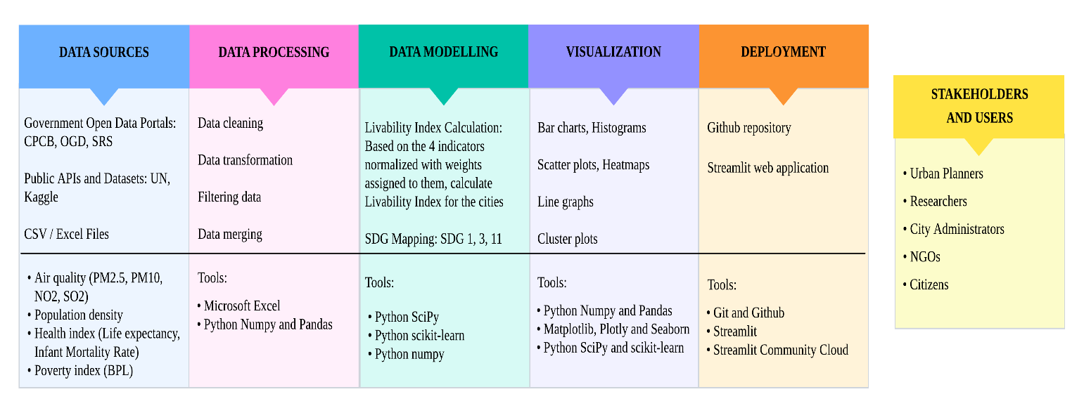
The project follows a standard Data Analysis Pipeline architecture comprising several sequential stages. It begins with Data Retrieval, where diverse sources are tapped to gather both Publicly Available Data (e.g., government statistics and reports) and Scraped Data. This raw input is then passed to the Data Pre-processing stage, which is essential for cleaning, transforming, and structuring the data into a usable format.
Once pre-processing is complete, the clean dataset serves two key purposes:
- Data Visualization: Charts, graphs, and interactive dashboards are created to highlight trends, patterns, and anomalies.
- Data Modelling: Statistical and analytical techniques are applied to extract insights or classify data.
The final stage involves Model Deployment, where the validated model is used to generate actionable conclusions and inform the project’s final recommendations based on the analyzed data.

4.2. UML – Use Case Diagram
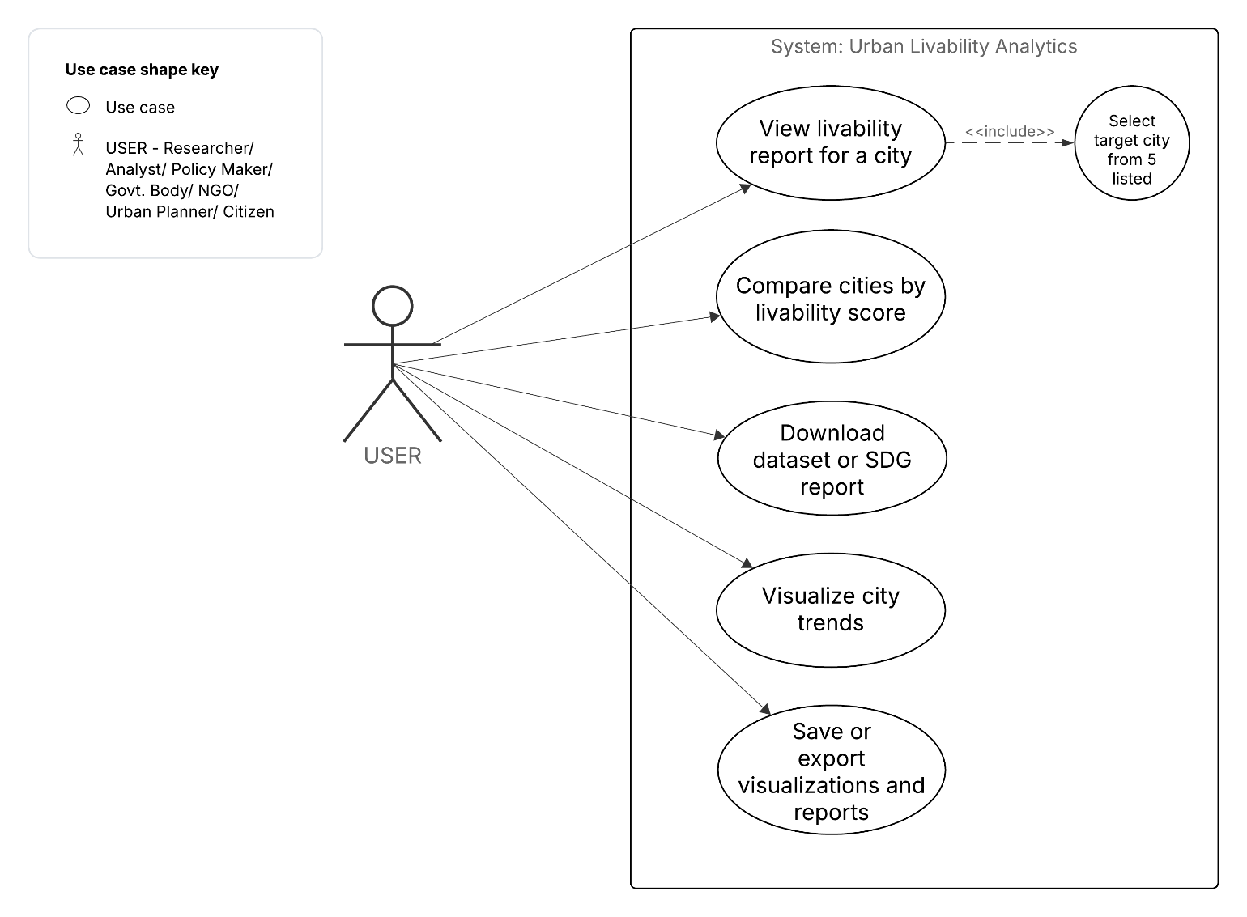
The UML Use Case Diagram illustrates how various stakeholders - including researchers, analysts, policymakers, government bodies, NGOs, urban planners, and citizens - interact with the system to assess and compare urban livability. Users can select a target city from a predefined list and perform key actions such as viewing detailed livability reports, comparing cities by livability score, downloading datasets or SDG reports, visualizing city-level trends, and exporting insights through saved visualizations and reports. This diagram highlights the system’s role in supporting data-driven urban planning and informed decision-making.

4.3. UML – Activity Diagram
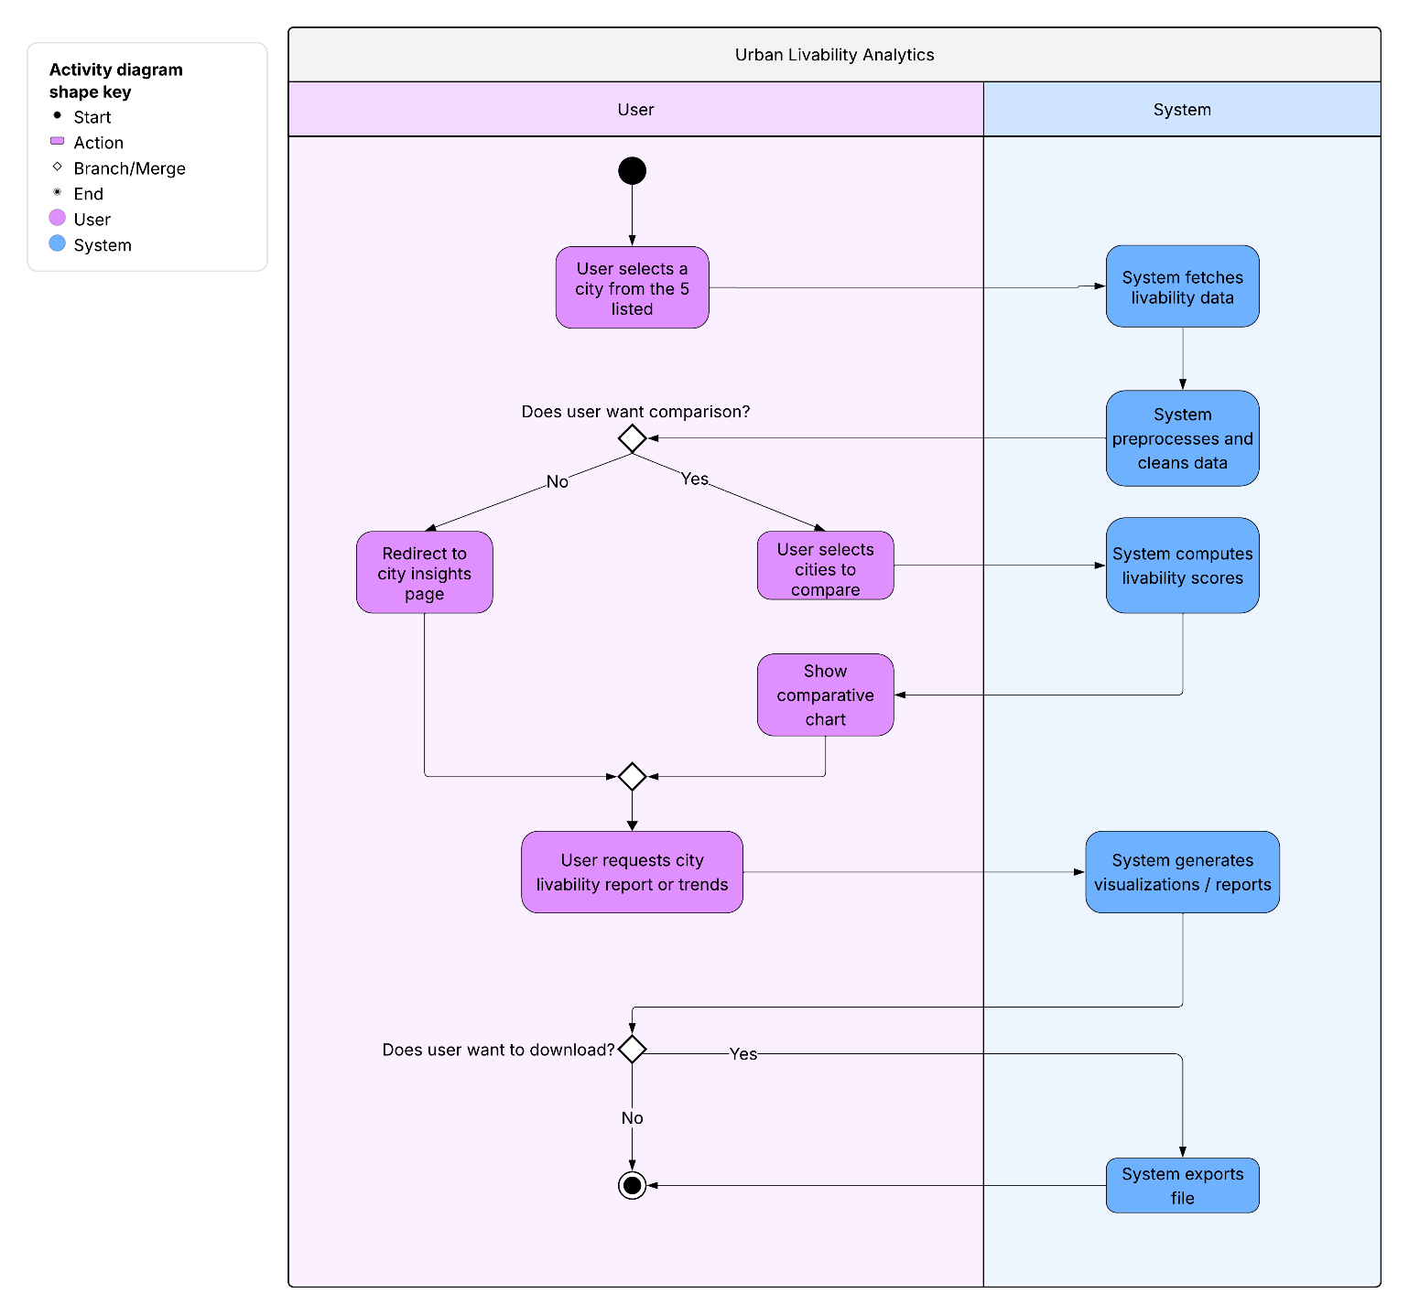
The UML Activity Diagram outlines a step-by-step workflow between the user and the system for analyzing city-level livability data. The process begins when the user selects a city from the list, prompting the system to fetch, clean, and preprocess relevant data before computing livability scores. Based on user choices, the flow branches to either viewing city insights, comparing multiple cities, show or download the visualizations. This structured diagram effectively captures the dynamic interaction and decision points involved in urban livability analysis.
4.4. UML – Class Diagram
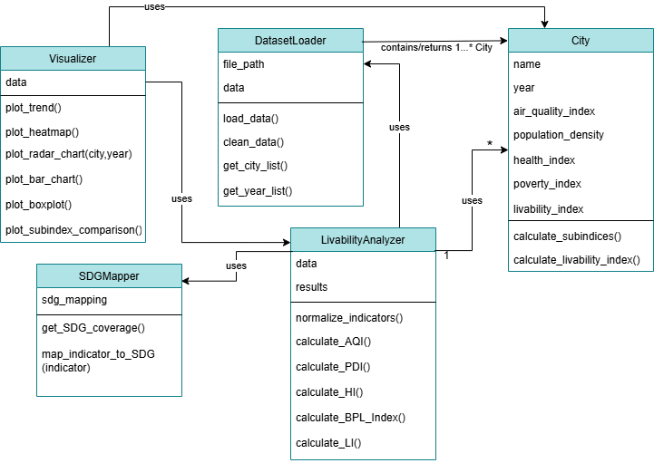
The UML Class Diagram represents the structural design of the Urban Livability Analysis System, outlining the main classes and their interactions. It includes five core classes:
- DatasetLoader – For loading, filtering, and merging of datasets from multiple sources for analysis.
- City – For city-specific data such as indicators and calculated livability scores.
- LivabilityAnalyzer – Performs normalization, weighting, and computation of sub-indices and the overall livability index.
- Visualizer – Generates visualizations such as line charts, heatmaps, and bar plots.
- SDGMapper – Maps the computed livability indicators to relevant Sustainable Development Goals for assessment.
The relationships between these classes depict the logical flow of data and ensure modularity and scalability within the system.
CHAPTER V
RESULTS
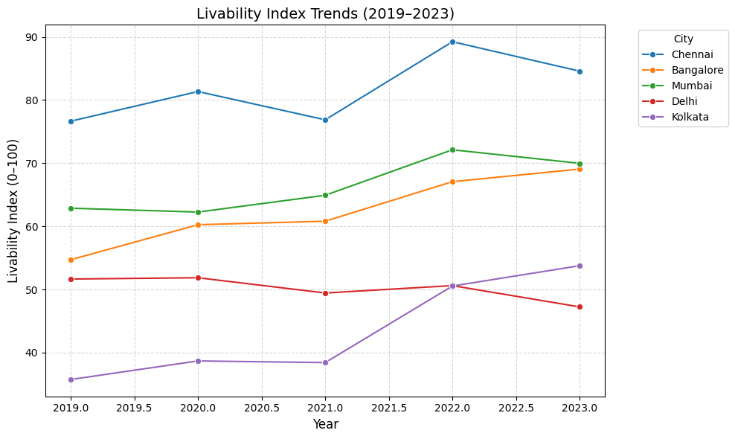
Figure 1
The line plot presents the temporal variation of the livability index for all five cities between 2019 and 2023. The line plot shows Chennai consistently holding the highest livability scores, while Delhi and Kolkata remain at the lower end across all years.

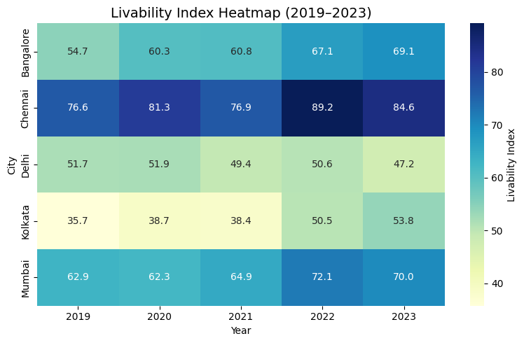
Figure 2
The heatmap displays the comparative livability index values of cities across the five-year period. The heatmap displays clear differences, with Delhi and Kolkata in darker shades, while Chennai stays in lighter tones across the years.
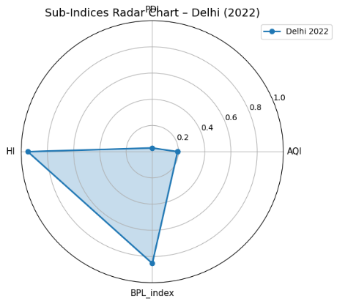
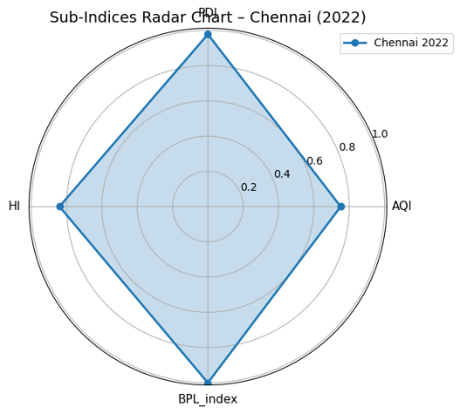
Figure 3
The radar chart illustrates the relative performance of Delhi and Chennai across four dimensions: air quality (AQI), population density (PDI), health index (HI), and poverty index (BPL).

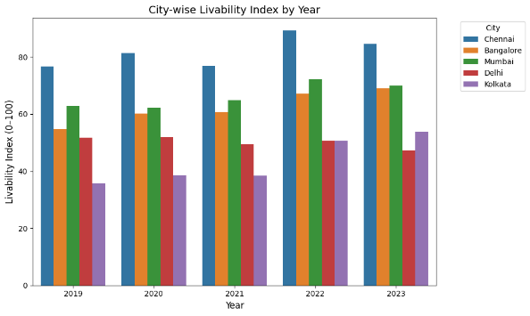
Figure 4
The grouped bar chart illustrates inter-city comparison of livability index scores within each year. The grouped bar chart demonstrates that Chennai consistently outperforms other cities in every year of the analysis, whereas Delhi ranks lowest throughout the period.

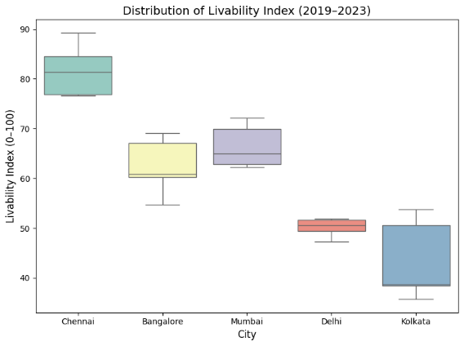
Figure 5
The boxplot summarizes the distribution of livability index scores for each city over the study period. The distribution analysis shows that Chennai exhibits a narrow and high-range spread of scores, whereas Kolkata demonstrates a wider distribution with notable upward shifts.

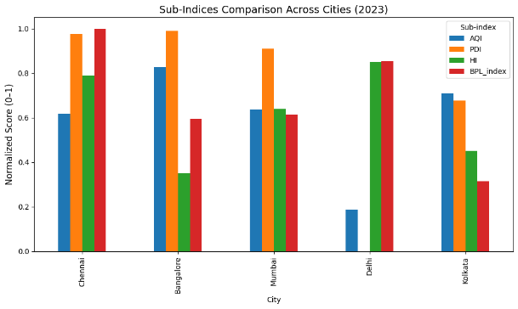
Figure 6
The grouped bar chart compares the normalized scores of four sub-indices - Air Quality Index (AQI), Population Density Index (PDI), Health Index (HI), and Below Poverty Line Index (BPL_index) - across the five cities for the year 2023. The sub-index comparison highlights Delhi’s weakness in AQI and PDI, whereas Chennai shows balanced performance across all dimensions.

CHAPTER VI

DISCUSSION
Figure 1: Chennai consistently achieves the highest scores, reflecting balanced performance across indicators. Bangalore shows moderate but steady improvement over the years. Mumbai remains stable with mid-range scores, suggesting incremental but limited progress. Delhi records the lowest values throughout due to poor air quality and density pressures, while Kolkata demonstrates gradual improvement, indicating gains in poverty reduction and health outcomes.

Figure 2: The color gradation highlights Chennai as the most livable city in the dataset. Bangalore and Mumbai occupy the middle range, with Mumbai slightly outperforming Bangalore in later years. Delhi remains consistently low, while Kolkata shows clear improvement, especially after 2021, signaling gradual policy effectiveness.

Figure 3: Chennai performs evenly across all four sub-indices, while Mumbai and Bangalore show moderate but uneven strengths. Delhi’s weaknesses in air quality and density dominate its profile, despite reasonable health outcomes. Kolkata demonstrates improvement in poverty and health, though environmental indicators still limit its overall livability.

Figure 4: Chennai leads in every year, followed by Mumbai and Bangalore, which are closely aligned. Kolkata begins at a low level but rises over time, narrowing the gap with mid-performing cities. Delhi remains lowest across the years, underlining persistent structural challenges.

Figure 5: Chennai’s compact and higher distribution indicates stability and resilience. Bangalore and Mumbai display mid-level consistency, reflecting moderate but stable urban conditions. Kolkata’s wider distribution suggests variability but also upward movement in livability. Delhi’s low and narrow spread demonstrates entrenched urban stress with minimal fluctuation.

Figure 6: Chennai shows strong and balanced scores across all sub-indices, reflecting well-rounded urban management. Bangalore performs well on population density but has noticeable gaps in health and poverty. Mumbai maintains moderate scores across all sub-indices but does not excel in any. Delhi stands out with very low air quality and population density scores but performs better in health and poverty indices. Kolkata achieves decent results for health and air quality yet falls short on poverty reduction, indicating uneven progress among its sub-indices. The visualization highlights where each city faces its greatest challenges and strengths, showing the need for city-specific policies to boost overall livability.

CHAPTER VII

IMPLEMENTATION

7.1. Application Overview

The analytical model developed for computing the Livability Index was further implemented in the form of an interactive web platform. The objective of this implementation is to bridge the gap between static data analysis and practical, user-oriented visualization, enabling stakeholders to easily interpret and compare livability parameters across cities and years.

7.2. Streamlit Web Application

The Streamlit web application was designed as a lightweight, multi-page dashboard that provides an intuitive interface for visualizing the livability metrics derived from this research. The key modules of the application include:

City Analysis Module – Displays sub-index values and overall livability index for a selected city and year.

Comparison Module – Enables comparison of multiple cities based on chosen years and indicators.

Visualization Module – Showcases analytical visualizations such as line charts, heatmaps, radar plots, bar graphs, and distribution plots to interpret patterns and trends.

Leaderboard Module – Ranks cities by their computed livability scores to provide a comparative overview.

The backend computations are performed using Pandas and NumPy for data processing, while Matplotlib and Seaborn are used for generating plots integrated into the Streamlit front-end. The application effectively transforms the research outcomes into an interactive and interpretable decision-support tool.

7.3. Sample code
# app.py
import streamlit as st
from utils import load_and_process

st.set_page_config(page_title="Urban Livability Dashboard", layout="wide")

st.title("Urban Livability Index — Interactive Dashboard")
st.markdown("""
This dashboard presents an interactive analysis of urban livability (2019–2023) for selected Indian cities.
It computes a composite Livability Index from sub-indices: **Air Quality (AQI)**, **Population Density (PDI)**,
**Health Index (HI)** and **Poverty Index (BPL)**. Use the pages in the sidebar to explore city-level trends,
comparisons, visualizations, and the leaderboard.
""")

# load data once and cache
@st.cache_data
def load():
return load_and_process("urban_data.csv")

df = load()

st.write("Dataset:")
st.dataframe(df)

App.py

Utils.py
# utils.py
import pandas as pd
import numpy as np

COND_TO_TDS = 0.67

def load_and_process(path="urban_data.csv"):
"""
Load CSV and compute subindices & livability index.
Returns processed DataFrame with lower-case columns.
"""
df = pd.read_csv(path)
df.columns = df.columns.str.strip().str.lower()

numcols = ["pm2.5","pm10","no2","so2","population","area","bpl_population",
"infant_mortality_rate","life_expectancy"]
for c in numcols:
if c in df.columns:
df[c] = df[c].astype(str).str.replace(",","",regex=False).str.replace("%","",regex=False)
df[c] = pd.to_numeric(df[c], errors="coerce")

if ("population" in df.columns) and ("area" in df.columns):
df["pop_density"] = df["population"] / df["area"]
else:
df["pop_density"] = np.nan
aq_indicators = [c for c in ["pm2.5","pm10","no2","so2"] if c in df.columns]
for col in aq_indicators:
denom = df[col].max() - df[col].min()
df[col + "_norm"] = (df[col].max() - df[col]) / (denom if denom!=0 else 1)
if aq_indicators:
df["aqi"] = df[[col + "_norm" for col in aq_indicators if (col + "_norm") in df.columns]].mean(axis=1)

if "pop_density" in df.columns:
denom = df["pop_density"].max() - df["pop_density"].min()

df["pdi"] = (df["pop_density"].max() - df["pop_density"]) / (denom if denom!=0 else 1)
else:
df["pdi"] = np.nan

if ("life_expectancy" in df.columns) and ("infant_mortality_rate" in df.columns):
le_denom = df["life_expectancy"].max() - df["life_expectancy"].min()
df["le_norm"] = (df["life_expectancy"] - df["life_expectancy"].min()) / (le_denom if le_denom!=0 else 1)

imr_denom = df["infant_mortality_rate"].max() - df["infant_mortality_rate"].min()
df["imr_norm"] = (df["infant_mortality_rate"].max() - df["infant_mortality_rate"]) / (imr_denom if imr_denom!=0 else 1)

df["hi"] = df[["le_norm","imr_norm"]].mean(axis=1)
else:
df["hi"] = np.nan

if "bpl_population" in df.columns:
denom = df["bpl_population"].max() - df["bpl_population"].min()
df["bpl_index"] = (df["bpl_population"].max() - df["bpl_population"]) / (denom if denom!=0 else 1)
else:
df["bpl_index"] = np.nan

subidxs = [c for c in ["aqi","pdi","hi","bpl_index"] if c in df.columns]
if subidxs:
df["livability_index"] = df[subidxs].mean(axis=1) * 100
else:
df["livability_index"] = np.nan

df["year"] = pd.to_numeric(df["year"], errors="coerce")
df["city"] = df["city"].astype(str)

df = df.sort_values(["city","year"]).reset_index(drop=True)
return df

CHAPTER VIII

LIMITATIONS
This study faces certain limitations. City-level data were not always available, requiring the use of district or state-level proxies that may reduce precision. The chosen normalization method (min–max scaling) is sensitive to outliers and dependent on dataset range, while the weighting scheme, though transparent, retains some subjectivity. Additionally, differences in data collection and reporting standards across sources may introduce bias, suggesting a need for more detailed and standardized datasets in future work.

CHAPTER IX

FUTURE SCOPE
To develop a more holistic and comprehensive understanding of urban livability aligned with sustainability standards, future research should incorporate a wider range of indicators beyond air quality, population density, health, and poverty. Including metrics that cover other aspects of infrastructural development and also social and economic development are essential for capturing sustainable urban development comprehensively.
Such expanded indicators would help align analyses more closely with the full scope of SDG related goals, enabling policymakers and urban planners to devise targeted interventions addressing multi-dimensional challenges. Leveraging emerging technologies like AI, IoT, and big data analytics can also support real-time data collection and smarter urban management strategies. Integrating these elements will support more resilient, inclusive, and sustainable urban growth in India’s rapidly evolving metropolitan landscapes.

CHAPTER X

CONCLUSION
In conclusion, this research analyzed livability conditions in selected Indian cities through the lens of Sustainable Development Goals, using recent quantitative data across air quality, population density, health, and poverty indicators. The findings show substantial variation in livability both between cities and across the measured sub-indices. Chennai stands out for its balanced and relatively high performance across all domains, suggesting that steady policy focus can generate urban improvements. In contrast, Delhi continues to face significant challenges, especially in air quality and density, while Kolkata demonstrates gradual progress in health and poverty reduction, albeit with uneven advances. Mumbai and Bangalore display moderate but uneven scores - Mumbai maintains steady performance across sub-indices, while Bangalore excels in population density and healthcare but faces challenges in other areas such as poverty and infrastructure.
These results emphasize that there is no single narrative for Indian urban livability: improvements in some cities and domains coexist with persistent constraints in others. Overall, while incremental gains are observable and align in part with SDG targets for sustainable, inclusive, and resilient cities, further city-specific and metric-specific interventions are needed to close the gaps and ensure equitable urban growth. A continued commitment to data-driven urban planning and sustained investment in lagging indicators will be essential to meet the goals outlined in UN’s SDGs and promote more livable, sustainable cities in India.
The Streamlit-based web application extends this research by translating analytical findings into an interactive, user-friendly platform. It enables real-time exploration of livability indicators, demonstrating how computational models can support urban planning, environmental monitoring, and sustainability decisions across major Indian cities.

CHAPTER XI

APPENDICES

11.1. Screenshots

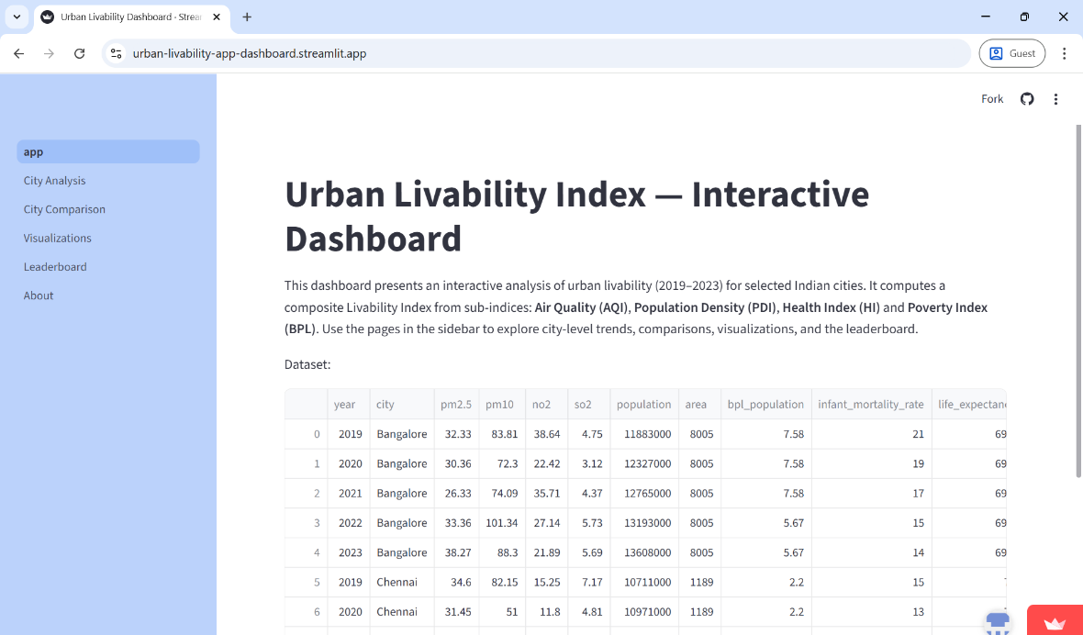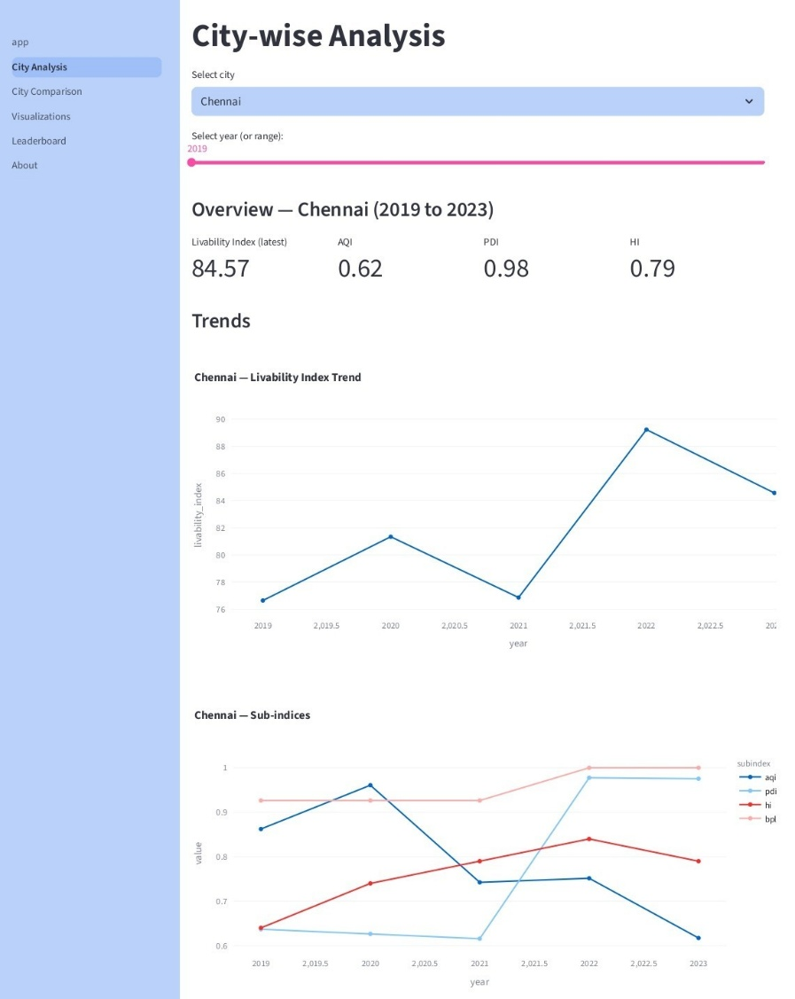

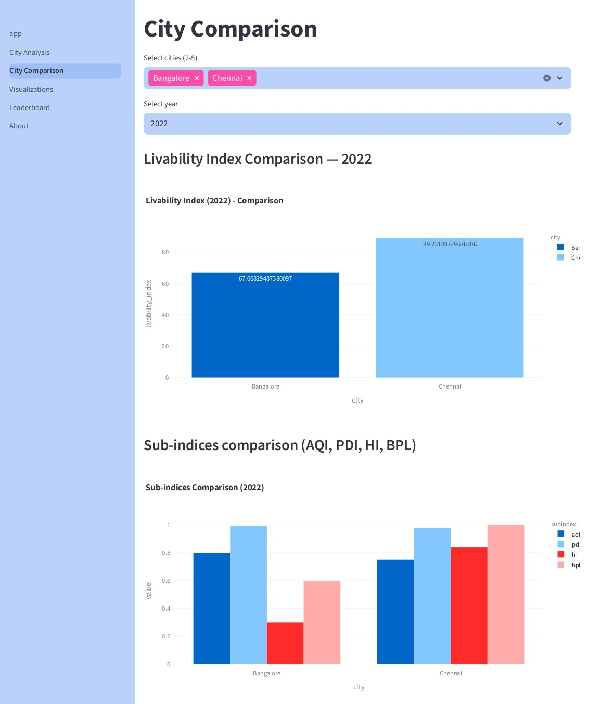

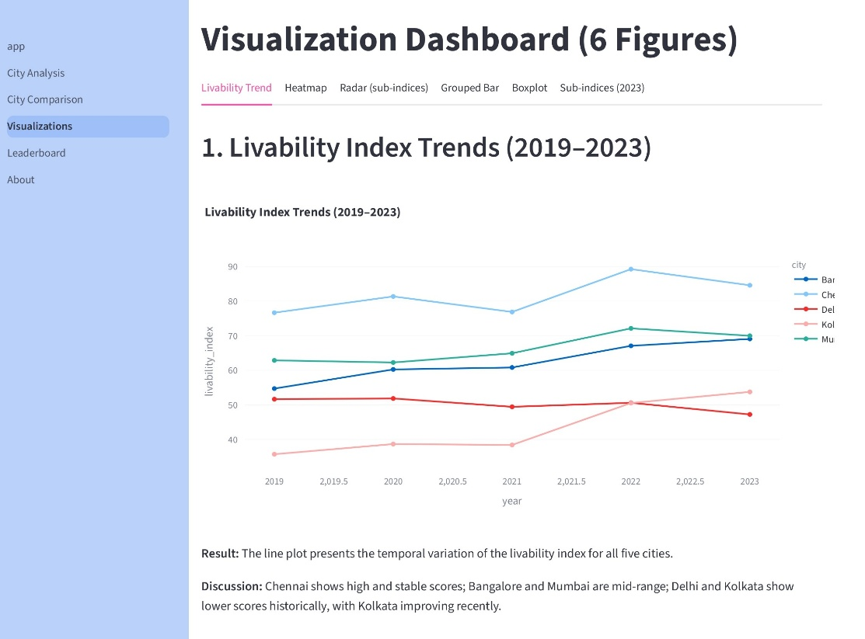

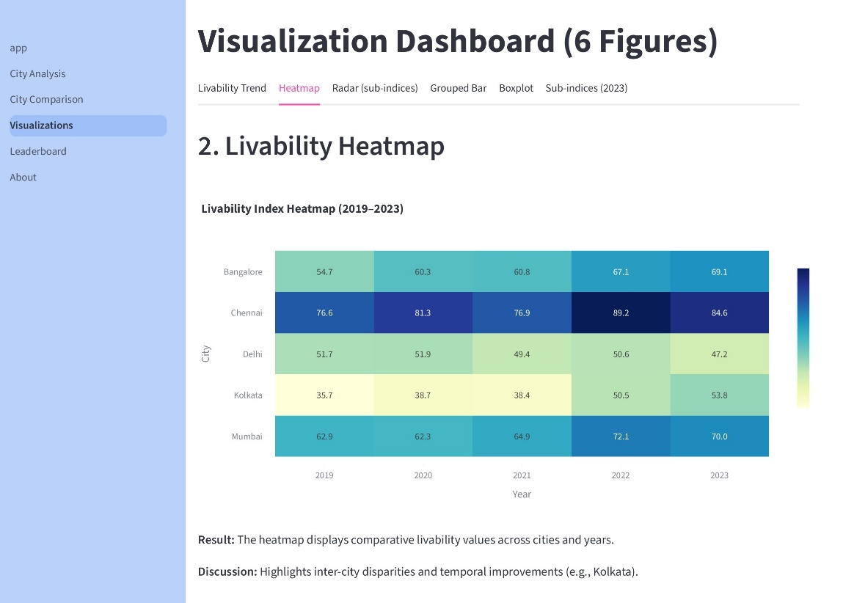

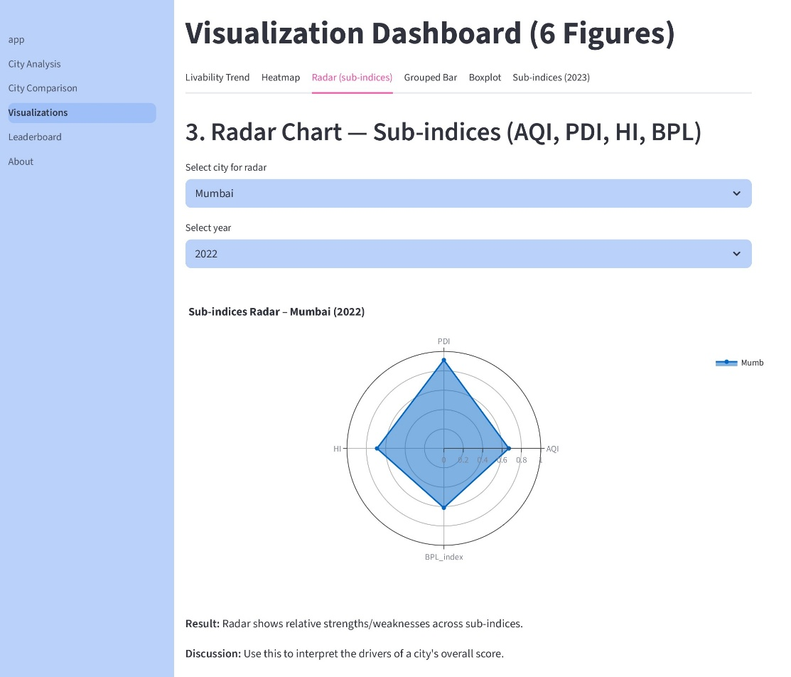

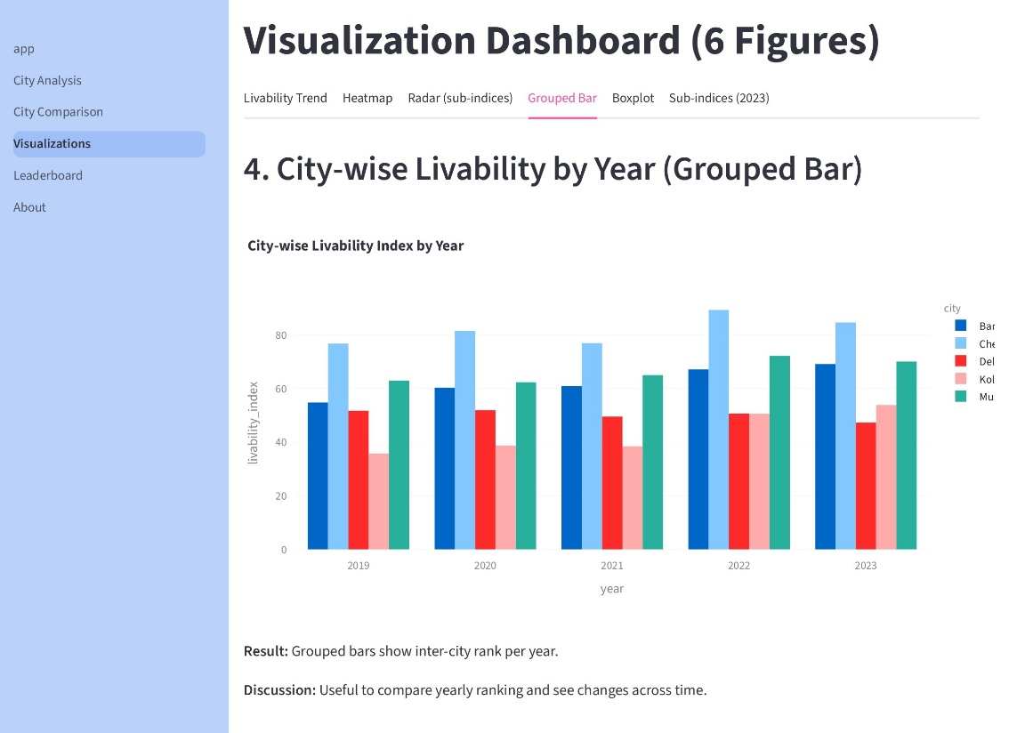

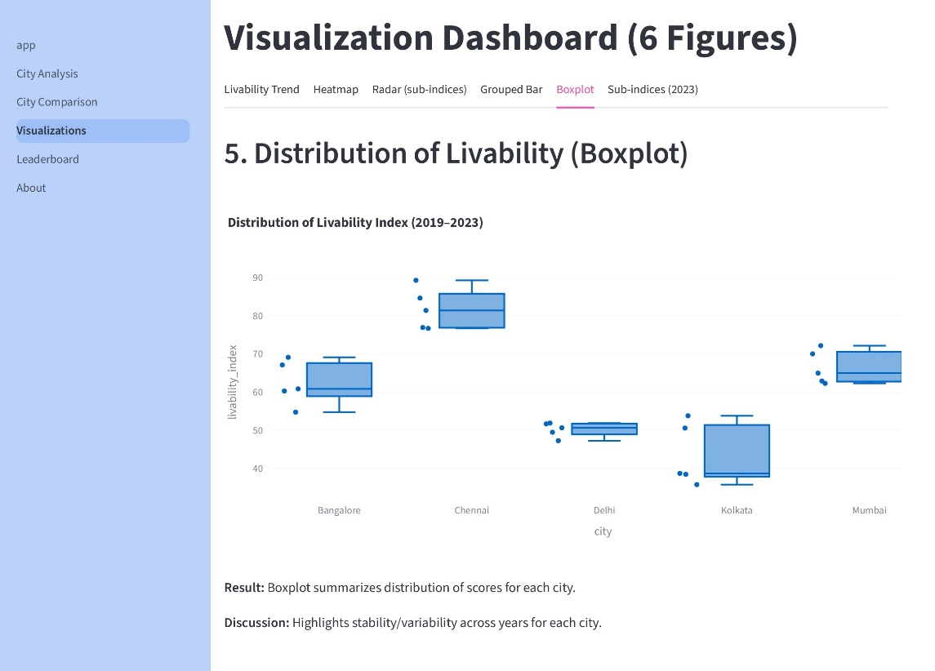

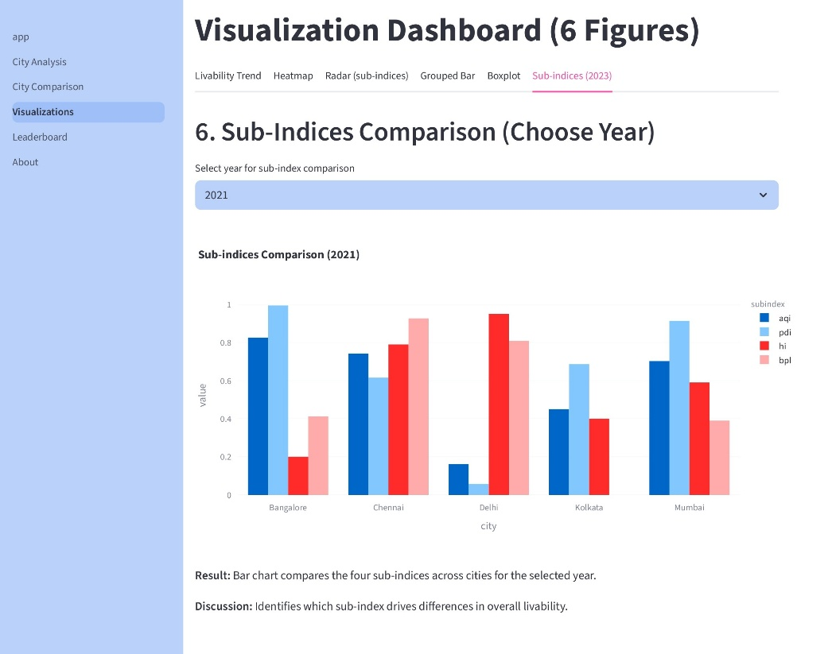

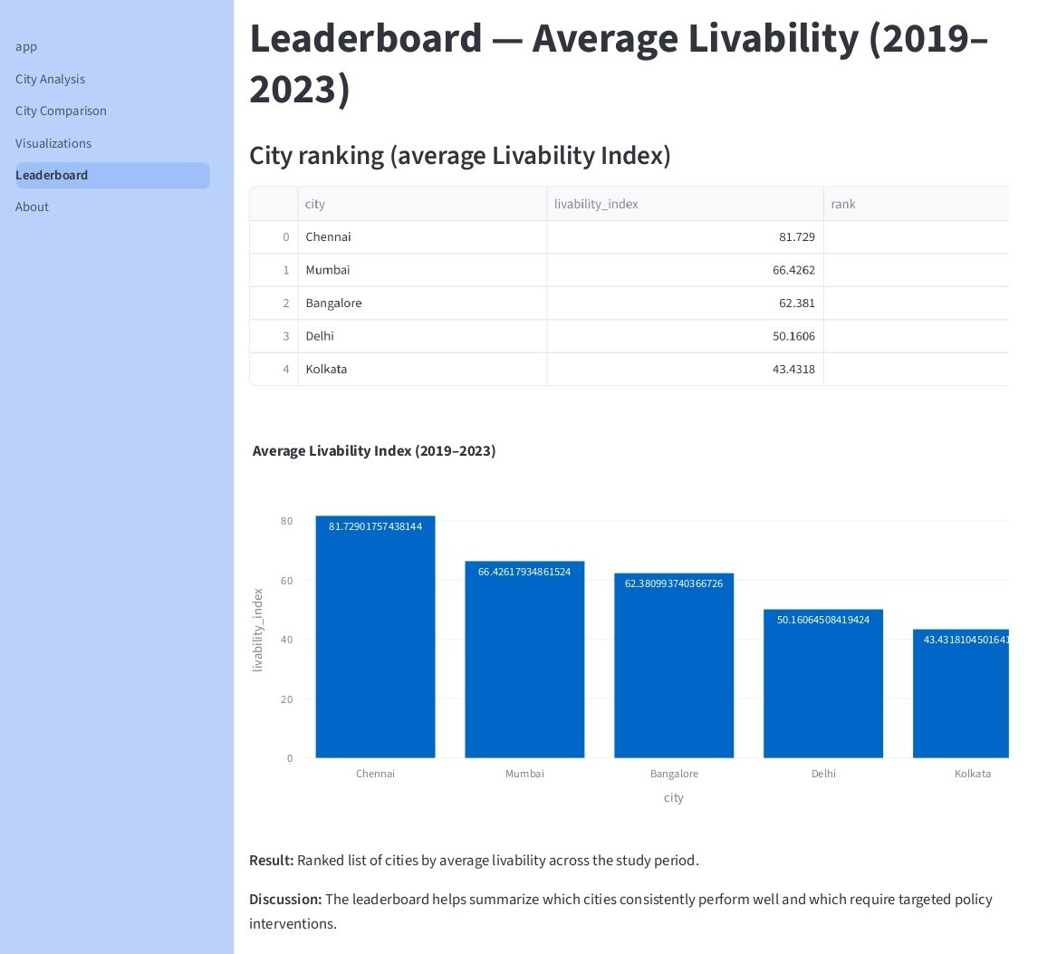

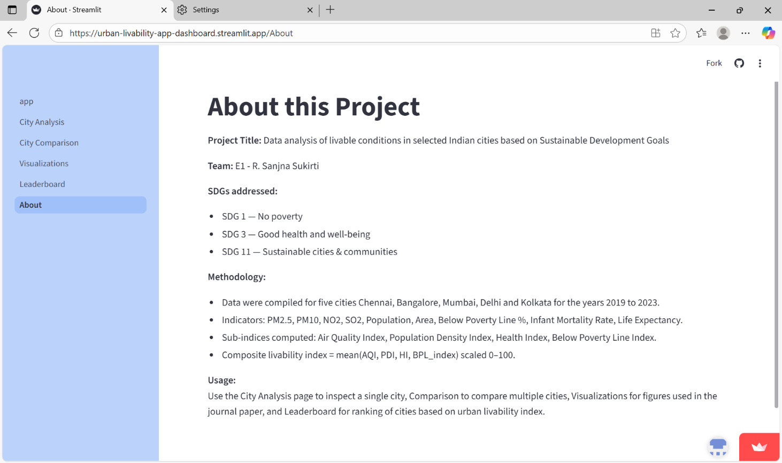

11.2. Dataset

CHAPTER XII
REFERENCES
[1] Shrikant Salve, Shubham Bombarde, A. Agrawal, Smruti Paldiwal, B. S. Roy, and Bhagyashree Alhat, “Livability-Analysis of People’s Living Comfort in Different Cities of India Using GIS: A Prototype,” HAL (Le Centre pour la Communication Scientifique Directe), pp. 163–168, May 2020, doi: https://doi.org/10.18573/book3.u.

[2] S. Shruti, P. K. Singh, and A. Ohri, “Evaluating the Environmental Sustainability of Smart Cities in India: The Design and Application of the Indian Smart City Environmental Sustainability Index,” Sustainability, vol. 13, no. 1, p. 327, Dec. 2020, doi: https://doi.org/10.3390/su13010327.

[3] U. Saeed, S. R. Ahmad, G. Mohey-ud-din, H. J. Butt, and U. Ashraf, “An Integrated Approach for Developing an Urban Livability Composite Index—A Cities’ Ranking Road Map to Achieve Urban Sustainability,” Sustainability, vol. 14, no. 14, p. 8755, Jul. 2022, doi: https://doi.org/10.3390/su14148755.

[4] Jayanandini G, Kathiravan P, and Suganthy Murugesh, “Evaluating The Urban Liveability Index With Data-Driven Insights Of Smart Cities Using Smart Innovative Solutions,” pp. 1–7, Nov. 2023, doi: https://doi.org/10.1109/aicera/icis59538.2023.10420047.

[5] “View of Review of Performance Indicators of Smart Cities in India –Ease of Living Index: a case of Lucknow Smart City,” Safer.uct.cl, 2025. https://safer.uct.cl/index.php/SAFER/article/view/445/403 (accessed Sep. 24, 2025).

[6] Z. Gareiou, Nectaria Gizani, Iro Laskari, I. Mavromati, and E. Zervas, “Review of composite environmental indicators,” E3S Web of Conferences, vol. 436, pp. 07002–07002, Jan. 2023, doi: https://doi.org/10.1051/e3sconf/202343607002.

[7] Shraddha Thorat, S. Pathak, and Harshad Raisoni, “Analyzing Liveability Index Parameters for Formulating Assessment Model at the Zone Level– A case of Pune City,” Zenodo (CERN European Organization for Nuclear Research), Sep. 2023, doi: https://doi.org/10.5281/zenodo.8397977.

[8] D. Subramanian, “Comparing Ease of Living parameters & Urban Greening Index,” E3S Web of Conferences, vol. 559, p. 04047, 2024, doi: https://doi.org/10.1051/e3sconf/202455904047.

[9] Y. Ran, W. Hou, J. Sun, L. Zhai, C. Du, and J. Li, “Coordination Analysis Between Urban Livability and Population Distribution in China’s Major Urban Agglomerations,” Sustainability, vol. 16, no. 23, pp. 10438–10438, Nov. 2024, doi: https://doi.org/10.3390/su162310438.

[10] P. R. Satiawan et al., “Towards a liveable city: Measuring the liveability index in Tuban Regency, East Java,” IOP Conference Series: Earth and Environmental Science, vol. 1353, no. 1, p. 012020, May 2024, doi: https://doi.org/10.1088/1755-1315/1353/1/012020.

[11] M. Yan, F. Yang, J. Shi, and C. Li, “Establishment of the Indicator System for Livable Cities Based on Sustainable Development Goals and Empirical Research in China,” Land, vol. 14, no. 6, pp. 1264–1264, Jun. 2025, doi: https://doi.org/10.3390/land14061264.

[12] B. Hande, Aydin Akpinar, Zeynep Sengul, Berfin Senik, Nur Hanife Orak, and Engin Sorhun, “Integrating Sustainable Development Into Urban Management: A Strategic Green City Index for Cities,” Sustainable Development, Jul. 2025, doi: https://doi.org/10.1002/sd.70050.

[13] R. C. R. RAJESHA C R and Prof. CHANDRASHEKARA. B. Prof.CHANDRASHEKARA B, “Exploring Urban Liveability: Frameworks and Approaches for Sustainable Cities,” Journal of Research in Humanities and Social Science, vol. 13, no. 3, pp. 31–38, Mar. 2025, doi: https://doi.org/10.35629/9467-13033138.

[14] S. Mostafa, A. Sharifi, M. Azari, and N. Tabrizi, “Spatial analysis and ranking of urban districts based on a comprehensive livability approach: the case of Tehran,” GeoJournal, vol. 90, no. 5, Aug. 2025, doi: https://doi.org/10.1007/s10708-025-11465-8.
‌

